**Spring 1**

**The children have certainly given me a warm welcome back, we have all had an exciting month so far and it is scary how quickly Year 1 is flying by! It was fantastic to see everyone’s brilliant outfits on ‘Dress 2 Express Day’. We discussed the importance of being unique and how best to show our emotions in the right way. Year 1 have also won the attendance award numerous times and have enjoyed time with the iPads, fruit kababs, a dance party and a lesson with Mr Hodgson!**

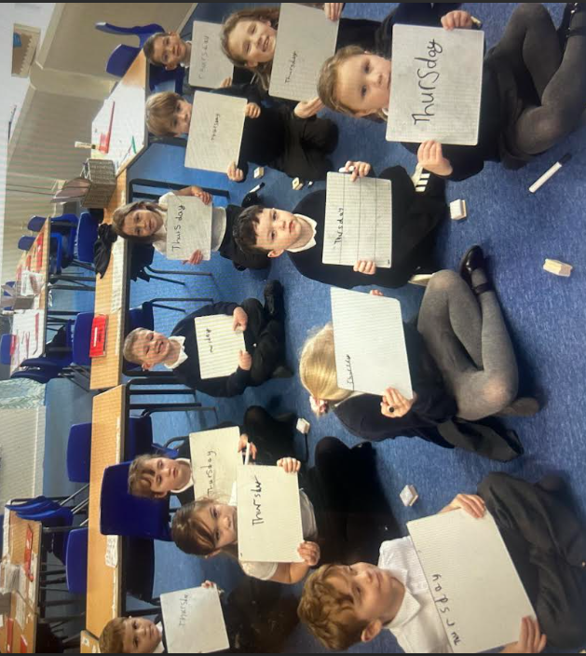

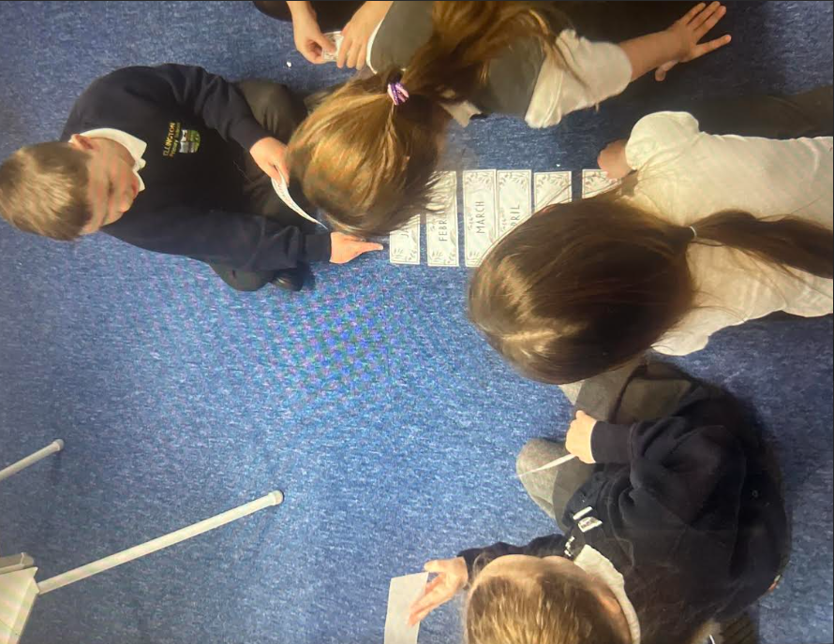**In Maths, we have been learning to tell the time to o’clock. The children have worked extremely hard and have picked this up quickly. Alongside focussing on days of the week and the months of the year.**

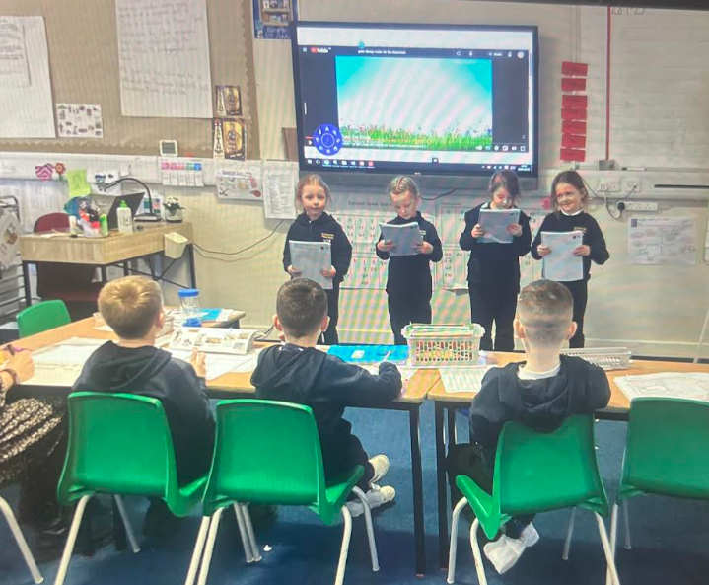**In English, the children have been reading their character descriptions aloud to an audience and focussing on adding expression. Then we have planned and written our own alternative ending to ‘Room on the Broom’. The children have been very imaginative and even had swimming pools coming out of the Witch’s cauldron!**

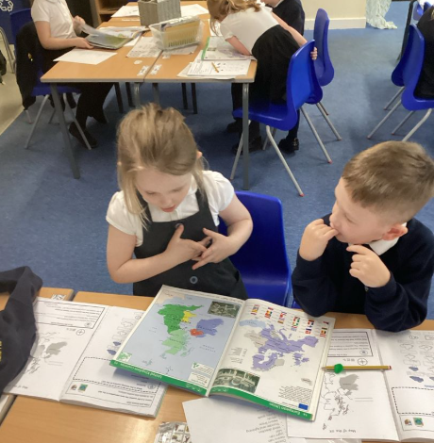**In Geography we have been looking at the countries that make up the United Kingdom and their capital cities. I have been extremely impressed with their retention of the capitals cities so please do quiz them!**

**We had our RE day focussing on Judaism. We started off by looking into what Jewish people believe in, where they worship and the events that take place during Shabbat. We enjoyed listening to how 10-year-old Charlie celebrates Shabbat with his family. This was followed by exploring Jewish festivals and acting out the story of Hanukkah.**

**Our class are making progress learning both their 10- and 2-times tables, I am really proud of their effort and perseverance. Please encourage your child to use both Numbots and TTRS at home as this will strengthen the children’s confidence in quick mental calculations. Next term we are really looking forward to World Book Day and all new topics we are yet to delve into!**

**Best wishes,**

**Miss McNickle**