

**Writing Intent, Implementation and Impact**

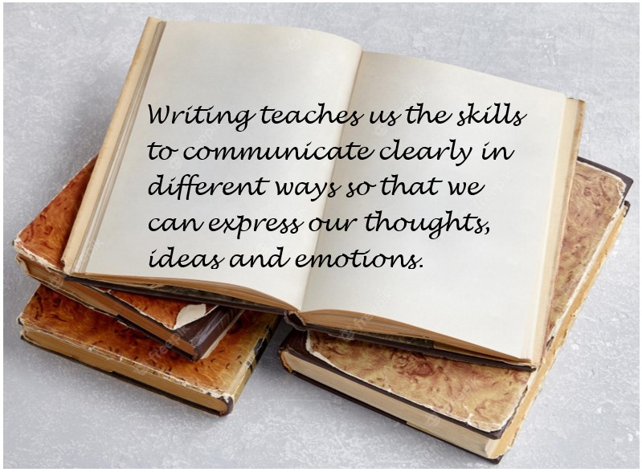

Through teaching the national curriculum, our intent is to inspire children with a love of reading and give them the skills to access and understand the wider world. Reading is key to unlocking all other subjects and, consequently, we approach this with a “no child left behind” mindset so that all children are supported and encouraged to develop fluency and comprehension.

Through reading, our children’s aspirations are developed as they become increasingly confident and acquire more knowledge and understanding, building upon - and broadening - their lived experiences. We encourage our children to think independently about what they have read, making connections and asking questions along the way.

[English National Curriculum KS1 & 2](https://www.gov.uk/government/publications/national-curriculum-in-england-english-programmes-of-study)

**Intent**

**Aspirations**

The literary world takes many shapes, sizes and holds a world of possibilities. Through a variety of carefully chosen and ambitious texts, children at Ellington are introduced to places beyond the school gates. Through rich stories, children meet significant people from the past and present around the world. Reading and being exposed to inspirational stories opens our minds to the possibilities of our future. We believe it is our responsibility to show children that there is a world of opportunities awaiting them and our carefully planned English reading and writing curriculum strives to encourage and promote reading and writing for pleasure. At Ellington Primary, we recognise that in order to provide a high-quality curriculum, which will help prepare our children for their future, children must have a secure foundation in all aspects of English. English is at the core of our aspirational curriculum as we aim to inspire children’s creativity and provide them with the fundamental skills to be able to access and achieve their potential in all subjects.

**Wider World**

Our English curriculum is an integral part of cultivating a child’s understanding of the wider world. Through access to a range of diverse texts, pupils have a chance to develop culturally, emotionally, intellectually, socially and spiritually. We harness the power of story; quality texts are at the centre of our reading and writing curriculum. A list of “100 Reads Before You Leave Ellington” has been devised to ensure our children are exposed to a strong range of high-quality texts in addition to those that are taught in our reading curriculum. Embedded within this list are cross-curricular texts that develop the Cultural Capital of our pupils. Alongside this, our writing curriculum utilises a range of engaging stimuli (visual texts, novels, short stories, picture books and inspirational people), which are mapped out and chosen in line with our curriculum drivers. We have a broad and balanced English curriculum and we are committed to our children being good communicators so they can express their thoughts and ideas fluently. Developing oracy is vital and enables children to build a variety of meaningful relationships that are free from exclusion. Children learn how to communicate respectfully whilst being tolerant of others beliefs.

**Independent Thinking**

Our English curriculum is paramount in developing independent thinking. We have carefully designed an English curriculum to provide our children with rich and varied learning opportunities to help them to become confident and enthusiastic learners. In turn, this encourages and supports independent thinking whereby children are able to independently express their emotions and ideas. At Ellington Primary, enabling children to become purposeful writers is something we value greatly. Rather than restricting the subject to the knowledge of the rudiments of writing (the rules of spelling and grammar), we focus on children being able to use the knowledge they have to produce purposeful, well-crafted, creative written work. We achieve this through our carefully planned ‘Ellington’s Approach to Writing.’ One example of this would be through our ‘create’ stage where teachers initiate pupil interest and engagement. Oracy is a key focus of our English curriculum as we believe that by improving spoken language skills, we are enabling children to communicate effectively and have a voice to be able to express their thoughts and ideas effectively. Children are encouraged to be active listeners and develop points made by their peers in a thoughtful and considerate way.

We encourage using a rich vocabulary in discussions. Debates, paired work, drama, group work and quiet independent work are all used in English lessons as a way of promoting independent thinking.

At Ellington Primary School, we recognise that in order to provide a high-quality education, which will help prepare children for their futures in education and beyond, children must have a strong foundation in all aspects of English: reading, writing, grammar and spelling. English is at the core of our curriculum and everything we do. We aim to inspire children whilst developing and providing pupils with essential skills and knowledge that are fundamental to unlocking all subjects in the curriculum as well as exploring and understanding the world around them. High quality texts are at the centre of our English curriculum, our aspiration is that children will become lifelong readers who are enthusiastic, engaged and who love to read. We know that reading is the gateway that makes all other learning possible. Our English curriculum closely follows the aims of the National Curriculum for English 2014 and is centred around our curriculum drivers: aspirations, tolerance, and independent thinking.

The English curriculum has been carefully mapped out to ensure key knowledge is taught and revisited throughout the year. Class teachers’ planning and delivery incorporates time to recap previous learning to build upon knowledge and understanding.

**Implementation**

At Ellington Primary School, enabling children to become purposeful writers is something we value greatly. Rather than restricting the subject to the knowledge of the rudiments of writing (the rules of spelling and grammar), we focus and intend on children being able to use the knowledge they have to produce purposeful, well-crafted, creative written work. 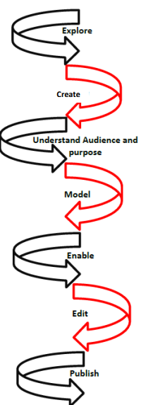

In our school, we use a variety of texts and text types in order to engage all children in writing and take inspiration from a variety of sources. We have a carefully mapped-out overview of age-appropriate stimuli and how they link to the specific purposes (see later in this explanation for more details) so that children can see that inspiration for writing can come from anywhere as well as allowing them to be exposed to cross-curricular links and the diversities that make up our world, thus ensuring our English curriculum contributes to our pupils’ SMSC education. We are continuously striving for a rich, broad and balanced curriculum. This overview includes high-quality short stories, picture books, visual stimuli and links to the novel being explored during reading lessons. Our aim is to fully immerse children within a range of high-quality texts that offer a wealth of writing opportunities to develop both an appreciation and love for writing and reading. In class, you will see children engaged and fully immersed in their writing journey and the language and opportunities it offers.

At Ellington, we have created our own ‘Writing Journey’ which is based upon research from the EEF guidance documents *‘Improving writing in…’* The writing journey follows 7 key steps, (see diagram and separate ‘Ellington Writing Journey’ document for further outline). These steps are not a ‘one stop’ process; rather they provide a key focus for a lesson. The steps of the journey are revisited throughout and ensure children are engaged in their learning and aware of the **purpose** and for their writing. The writing journey is evident when entering classrooms, upon working walls, in children’s books and children can confidently explain their learning. Working Walls reflect current learning, such as current text and the audience and purpose in which children are writing for.

We highly value the consideration of purpose and audience. It is found to support effective writing. At Ellington Primary School, we recognise that children will benefit from having a reason to write and someone to write for. This can include the pupils themselves being the audience, using their writing to clarify and organise understanding. There are four main purposes of writing: to entertain, to inform, to discuss and to persuade. We believe that teaching children to understand the power of writing is an important part of our job as teachers. We believe that if we equip the children with the correct writing tools, they will be able to use them effectively within a literate world.

Children at Ellington Primary School are provided with a stimulating writing environment in which we offer encouragement and good quality modelling of writing. We have clear expectations of writing and communicate these targets to the children. We have high expectations of the finished writing product and encourage the children to maintain the same standards at all times. Our children learn to write for a range of audiences and purposes. Throughout the teaching and learning of writing, our pupils develop an understanding of how to write a broad range of text types. Our writing for a purpose approach is supported by Michael Tidd’s writing for four purposes and EEF literature.

We believe that teaching children to understand the power of writing is an important part of our job as teachers. Therefore, at Ellington Primary, our aim is to equip our children with the correct writing tools so that they will be able to use them effectively within a literate world. Entering any classroom at Ellington Primary School, you will see children aware of purpose, audience as well taking pride in their work. Children go through the ‘writing journey’ which is evident in their English books and then publish their work in their ‘publishing books’ as well, using this step to publish for displays and their wider audience.

What will I see if I visit an English lesson at Ellington Primary School?

**Creative, enthusiastic, and passionate teachers:** At Ellington Primary School, we love learning. Class teachers value the importance of English writing and reading and work together, alongside subject leads, to weave all aspects of English into lessons to make learning purposeful as well as exciting. We are **reading and writing teachers** and we model and share a love of reading and writing to our pupils. This is exemplified in lessons, everyday talk with the children and throughout the school environment.

**High-Quality texts and exciting stimuli:** Each carefully-planned reading and writing unit is supported by high-quality texts and stimuli to inspire a wealth of writing. Our children are excited by them and enjoy exploring each new text in order to develop their ideas and ignite their passion to write.

**Clear and detailed instruction, explanation and modelling:** We understand the importance of teaching instruction being explicitly clear and tailored to individual needs. When building up to our final writing purpose, the use of purposeful learning intentions and clear modelling of good and bad examples ensures expectations are clear for children. Modelled writing is explicitly outlined and built into our ‘Writing Journey’, modelled writing takes different forms depending on the lesson objectives, but it always remains clear, and explicit. Modelling is used as a scaffold for independent learning.

**Quality talk:** Children are given frequent opportunities to share thoughts and opinions through a variety of different prompts. The use of “talk partners” is carried from the RWI approach into English lessons and children are encouraged to share their opinions. They are encouraged to extend their own and their peers’ thinking to help deepen their understanding of the class text or writing.

**Encouragement of engaging and useful vocabulary:** Through their reading and the models used for writing, pupils are introduced to a range of vocabulary suitable for their text type. They are encouraged to explore this and emulate it in their own writing. When writing to entertain, we employ the use of the “Descriptosaurus” to enable pupils to build their own engaging sentences and develop increasingly complex sentences. Our non-fiction units allow us to discuss levels of formality and other appropriate vocabulary, such as the use of technical language in non-chronological reports.

**Accurate and precise use of language and grammar:** To provide consistency throughout the curriculum, staff model appropriate use of standard English as well as encouraging the children to speak in full sentences when discussing and answering questions. This allows the children to hear correct use of grammar before applying it to their written work.

**Retrieval of key knowledge:** As previously mentioned, across school we have developed several strategies which support children in their recall and retention of key knowledge. Every English lesson begins by drawing upon and building on previous lessons and skills taught.

**Beautiful work:** At Ellington Primary School, we celebrate beautiful work. As mentioned, we follow EEF guidance along with Michael Tidd’s writing for a purpose and with this, children plan, draft and publish beautiful work for a range of different purposes. This work is created in their publishing book alongside work for display and other purposes. This is driven by our value of **Pride** whereby we teach children the importance of presentation and carefully planned work. We encourage beautiful presentation and development of handwriting through our twice-weekly handwriting lessons that follow the “Letterjoin” scheme of work.

**Impact**

Over the last two years, we have refined the Ellington Writing Journey and all staff now fully understand what each stage consists of and ways in which to implement it to ensure children achieve appropriate learning outcomes. The children now cover a wide range of text types inspired by a range of powerful and engaging stimuli, ranging from extracts of novels to short films, which (through pupil and staff voice) is proven to engage them in extended writing.

Further to this, we have developed a clear system of assessment through the use of writing objective grids that staff update with regularity - highlighting met targets based on evidence in books - and the children also access them so that they are aware of gaps in learning. This has allowed internal data to become more accurate and staff to set expectations throughout each unit of writing. Consequently, internal data reflects a steady improvement in outcomes.

Books showcase the children’s increasing pride in their work as well as their successes in learning and applying a range of age-appropriate SPAG skills as dictated by the National Curriculum.

In KS1 Writing, 77% of children achieved the expected standard in 2022 compared to 58% nationally. In 2023, 77% of children achieved the expected standard in 2023 compared to 58% nationally.

In KS2 Grammar, Punctuation and Spelling, 81.8% of children achieved the expected standard, the Local Authority average was 70.1%, the national average was 72%. The Local Authority Greater Depth average was 24.8%, nationally this was 30%, we achieved 36.4%.