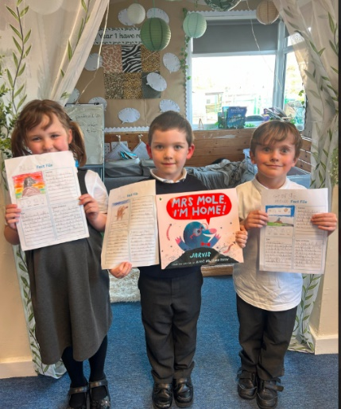**Year 1 News**

**March has been a busy but exciting month in year 1! We have been reading Mrs Mole I am home! The children empathised with Mr Mole throughout the story when he thought he had reached his home. They thought carefully about how Mr Mole might have been feeling throughout the story and wrote fantastic pieces of writing. Next, we were introduced to the features of fact files, learning the difference between facts and opinions. This week we have researched about Moles and worked hard to create our own fact files.**

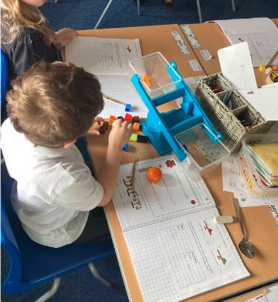**In Maths, we have been focussing on comparing the mass of objects through discussions and practical activities. This week we are looking at addition and subtraction both on a number line and counting on using our fingers and in our heads, I am so impressed with the children’s speed at calculations.**

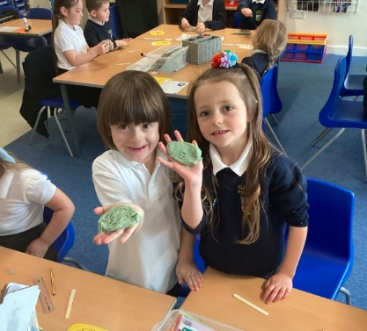**In Science, the children have thoroughly enjoyed our learning all about the five different animal groups, I have been particularly impressed with their ability to write and explain verbally the difference between the different animal groups.**

**In History, our new topic is Toys in the past. We have been sharing our own favourite toys and giving reasons for our answers. We are beginning to think about questions we can ask our parents and grandparents about their favourite toys to compare to ours, so please do share these with your children.**

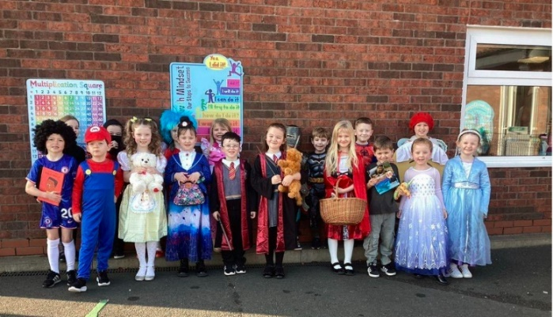**We are very excited for Comic Relief, a morning with Mr Bailey to link our curriculum learning with online activities and of course the Easter trail.**

**Best wishes, Miss McNickle**