

**Reading Intent, Implementation and Impact**

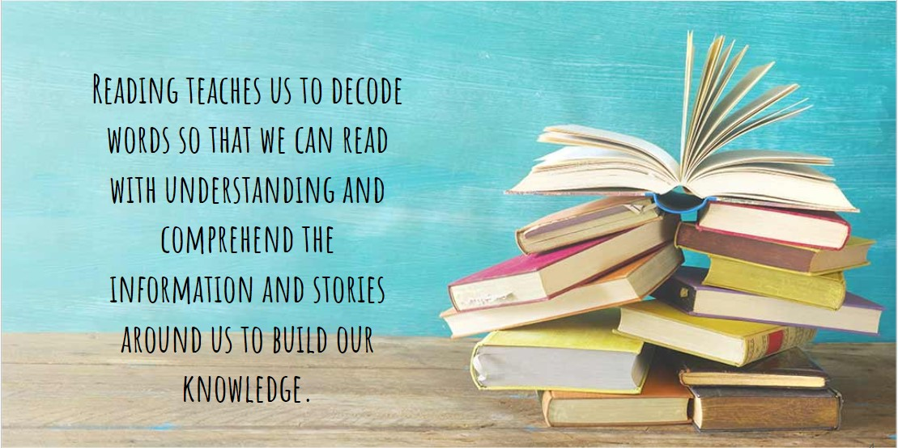

Through teaching the national curriculum, our intent is to inspire children with a love of reading and give them the skills to access and understand the wider world. Reading is key to unlocking all other subjects and, consequently, we approach this with a “no child left behind” mindset so that all children are supported and encouraged to develop fluency and comprehension.

Through reading, our children’s aspirations are developed as they become increasingly confident and acquire more knowledge and understanding, building upon - and broadening - their lived experiences. We encourage our children to think independently about what they have read, making connections and asking questions along the way.

[English National Curriculum KS1 & 2](https://www.gov.uk/government/publications/national-curriculum-in-england-english-programmes-of-study)

**Intent**

**Aspirations**

The literary world takes many shapes, sizes and holds a world of possibilities. Through a variety of carefully chosen and ambitious texts, children at Ellington are introduced to places beyond the school gates. Through rich stories, children meet exciting characters and meaningful protagonists throughout time and place. Reading and being exposed to inspirational stories opens our minds to the possibilities of our future. We believe it is our responsibility to show children that there is a world of opportunities awaiting them and our carefully planned Reading Curriculum strives to encourage and promote reading for pleasure. At Ellington Primary, we recognise that in order to provide a high-quality curriculum, which will help prepare our children for their future, children must have a secure foundation in all aspects of English. English is at the core of our aspirational curriculum as we aim to inspire children’s creativity and provide them with the fundamental skills to be able to access and achieve their potential in all subjects.

**Wider World**

Our English curriculum is an integral part of cultivating a child’s understanding of the wider world. Through access to a range of diverse texts, pupils have a chance to develop culturally, emotionally, intellectually, socially and spiritually. We harness the power of story; quality texts are at the centre of our reading and writing curriculum. A list of “100 Reads Before You Leave Ellington” has been curated to expose children to a range of stories that allow the children to widen their thinking by exposing them to key issues, protected characteristics and other cultures. Alongside this, our writing curriculum utilises a range of engaging stimuli (visual texts, novels, short stories, picture books and inspirational people), which are mapped out and chosen in line with our curriculum drivers. We have a broad and balanced English curriculum and we are committed to our children being good communicators so they can express their thoughts and ideas fluently. Developing oracy is vital and enables children to build a variety of meaningful relationships that are free from exclusion. Children learn how to communicate respectfully whilst being tolerant of others beliefs.

**Independent Thinking**

Our English curriculum is paramount in developing independent thinking. We have carefully designed an English curriculum to provide our children with rich and varied learning opportunities to help them to become confident and enthusiastic learners. In turn, this encourages and supports independent thinking whereby children are able to independently express their emotions and ideas.

Our reading lessons offer a wealth of opportunities for children to think for themselves, forming opinions about characters and their development, their feelings, thoughts and motives; themes; plotlines; and authorial intent including language choice. Through opportunities for drama and practical activities, children get to think about and make choices about presenting their thoughts and ideas as well as how they interpret those that the author intended.

**Implementation**

What will I see if I visit a RWI Phonics lesson at Ellington Primary School?

**Quality-First Teaching -** All staff delivering the phonics programme undergo regular training to ensure all our children receive high quality lessons to give them the best start to their learning. Staff are enthusiastic and encouraging towards the children.

**Silent Signals:** To ensure a focused and fast-paced learning environment, silent signals are utilised within each group. This allows for consistency for the children as they move through the groups and that the sounds/words being explored within the lesson are the main focus.

**Daily Speed Sounds Lesson:** During this time, children will be introduced to a new sound each day from Monday to Wednesday and the sounds are recapped Thursday and Friday. This part of the session consists of “Special Friends, Fred Talk, Read the Word” followed by “Fred in Your Head, Read the Word” and finally “Speedy Reading”. Spelling of new and review words is also incorporated uing “Fred Fingers”.

**Storybook Lesson:** Children are introduced to a new storybook every week and during this part of the session, children will learn new “Story Green Words” relating to the book then they will review “Speedy Green Words”, which have been previously taught. In addition, “Red Words” are taught in accordance with the book colour. There are also opportunities for children to read independently, modelling and asking and answering questions. Twice a week, there are opportunities for writing and proofreading.

**Weekly Spelling lesson:** On a Friday, the children take part in a spelling lesson rather than a storybook lesson. They complete a spelling test of previously taught words and red words and are then introduced to the new list for the following week.

**A positive and supportive environment:** In these sessions, children’s successes are celebrated as well as others being strategically supported through the identification of “Spotlight Children”. The repetitive nature of the RWI phonics programme allows for over-learning and consolidation of words and sounds.

**Immediate feedback:** Children are supported and encouraged to self-mark their work to allow them to understand where errors have been made and how to fix them.

**Targeted interventions:** Outside of the main RWI lessons, Fast-Track phonics interventions take place to support the B20% of each year group (R - 2 and those that still require intervention in Years 3 and 4). Individual Progress Records identify children’s gaps and 1:1 interventions take place 4 times a week to target these specific needs.

What will I see if I visit a Reading Comprehension lesson at Ellington Primary School?

**Quality-first teaching:** Reading comprehension lessons should be planned and delivered to ensure that all children are being exposed to and accessing age-appropriate texts, once they have completed the RWI phonics programme.

**Shared reading of a high quality text:** Language-rich texts have been chosen and progress over the year groups. Each lesson begins with the shared reading of a small section of the class novel; this can be done either by the class teacher to allow children to develop their internal reading voice or through “popcorn” reading, whereby children can choose each other to read. This allows the children to develop their confidence in reading aloud as well as expression and fluency.

**Targeted and skillful questioning:** Throughout the shared reading, targeted questions are discussed verbally to ensure children access a range of skills and question types (VIPERS approach) as well as check the children’s understanding of the text. This is known as “Book Talk”. Teachers should be targeting specific children with appropriate questions.

**Range of activities:** Throughout a two-week cycle, the children will access four written tasks, 2 practical activities and 1 “Cold Comprehension”. The remaining sessions allow time for extended shared reading and “Book Talk”. The written tasks use the VIPERS approach to focus on one skill at a time using a range of assessment-style questions and other engaging activities. The practical activities give children opportunities for speaking and listening, debating, drama and Reader’s Theatre to name a few. The “Cold Comprehension” ensures that children are continuing to access new and unfamiliar texts, working independently to answer questions in timed conditions. These are then marked together to ensure immediate feedback.

**Scaffolded resources to support B20%:** Written resources should be scaffolded to support success and ensure children are focusing on the skill at hand.

**An enthusiastic and supportive reading environment:** Teachers read with expression and enthusiasm, drawing children into the stories; working walls support children’s recall and model answers; opportunities for partner and group talk facilitate discussion whilst building answers and confidence; reading displays promote a love of learning; and children are provided with opportunities to express their thoughts and ideas.

**Targeted interventions:** Outside of lessons and based on children identified in Pupil Progress Meetings, reading comprehension interventions take place to further support children with the skills required to understand the texts they read. Children who do not read regularly at home are also listened to throughout the week by trained staff.

In addition to reading lessons, reading for pleasure is promoted in the following ways:

**Storytime**: This session is timetabled daily for every year group and is a time for children to relax and listen to their teacher read in an engaging way.

**100 Reads list**: A list of “100 books to read before you leave Ellington Primary” has been developed to ensure our children are exposed to a range of text. They are woven into the Reading Curriculum as well as into the stories selected for storytime.

**Reading Incentive**: To encourage children into the habit of reading at home, a reading incentive is in place whereby children can earn rewards for every time they read at home and detail this in their Reading Record.

**Accelerated Reader**: In order to structure the children’s independent reading following phonics, Accelerated Reader is in place to ensure children are reading at an appropriate challenge point. They then complete a quiz following their reading to ensure they have understood the text. Half termly Star Reader tests are in place to enhance assessment and inform interventions etc.

**Impact**

At Ellington, we strive to ensure that all our children become confident and fluent readers so that the rest of the curriculum is open to them as learners.

Over the last two years, we have reconstructed reading lessons to ensure they are daily as well as introducing storytime sessions in the afternoon. The daily reading lesson has ensured that children are exposed to a wide range of language-rich texts, which they can - and do - discuss with enthusiasm, and teacher questioning has improved comprehension skills and children’s ability to analyse texts.

As a result, in KS1, 85% of children achieved the expected standard in 2022 compared to 67% nationally. In 2023, 80% of children achieved the expected standard in 2023 compared to 69% nationally. In KS2, 81.8% of children achieved the expected standard, the Local Authority average was 72.7%, the national average was 73%. The Local Authority Greater Depth average was 27.5%, nationally this was 29%, we achieved 31.8%.

After extensive training to ensure staff expertise, Ellington’s use of the RWI phonics programme is fully embedded and having a positive impact on pupil attainment, including the use of Fast-Track interventions to ensure accelerated progress. Results in the 2023 PSC demonstrated attainment of 87% in Year 1 and 97% in Year 2.

Reading for prosody is improving throughout the school with children being able to read with greater intonation, expression and acknowledgement of punctuation. They have frequent opportunities to do so during lessons - as well as hearing well-modelled teacher reading - and often volunteer to read aloud in front of the class.

Accelerated Reader data has also shown a marked improvement in the children’s average reading ages across Years 2-6.