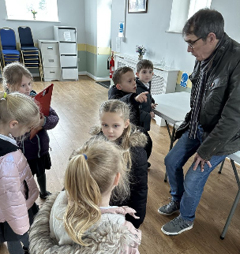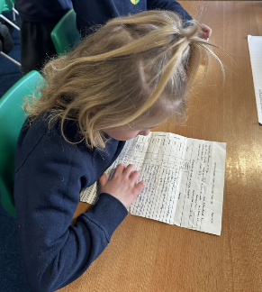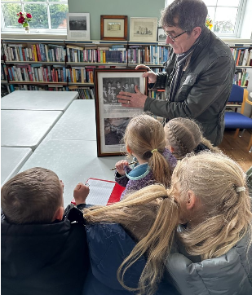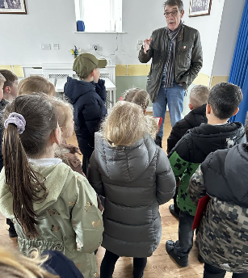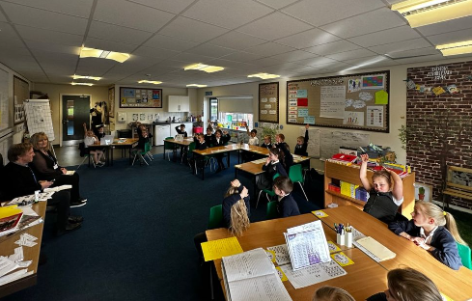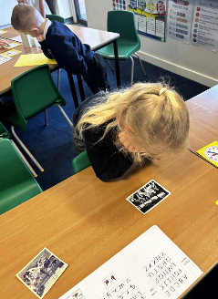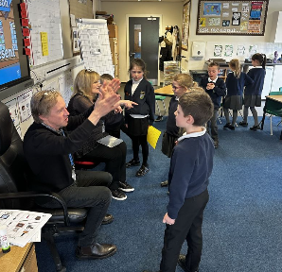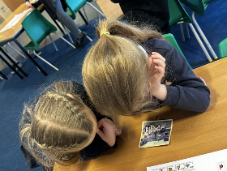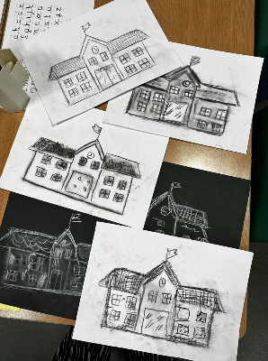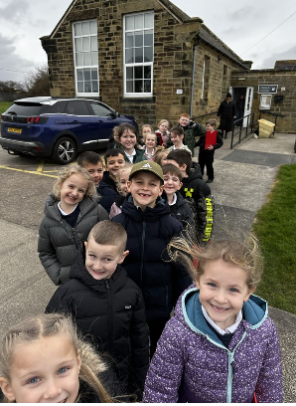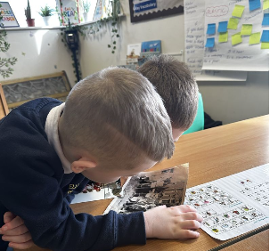

We interviewed Mrs Sayer and Mr Liddle who both went to school in Ellington, we asked them many questions about how schools have changed and we heard many fantastic stories. Mrs Sayer also shared photos of her during her school days and we got to see her old school report!

We also took a trip to the old primary school which was the first school built in Ellington in 1837, it is now the local village hall. Mr Jackson helped us with our learning as he told us some very interesting facts about the village and how it has changed over the years.

YEAR 2 – Celebrating Ellington

HOW HAVE SCHOOLS CHANGED OVER TIME?